CHURCHES TOGETHER IN HEREFORDSHIRE NEWSLETTER MARCH 2023


Hello. If you would like to send me any information for the April 2023 newsletter, please send it by 25th March. Thank you!

Imagine Church Envisioning Evenings | LICC
Part 2: 6 March | 7:15pm - 9:00pm
Tickets are still available to buy!
Join Steve Rouse, Church Team Director, as he shares what LICC has learnt about how to create a whole-life disciplemaking church and helps you identify next steps for your context. LICC is an organisation that is passionate about empowering Christians and helping church leaders help their own church communities and equip them with the tools that will help them spread the Gospel.
Running across two evenings to fit around busy work schedules, this workshop is designed specifically for ministers and church leadership teams to come together and discover:
The biblical vision for wholelife disciple-making:
- The principles, practices and processes that make whole-life disciplemaking possible
- Case studies and examples that embed those principles in real life contexts
- A framework and next steps for creating a whole-life disciplemaking culture in your church
- If you would like to find out more, click the link: https://licc.org.uk/ events/churchenvisioning-evenings/


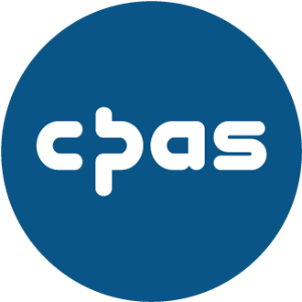

FIVE INSIGHTS TO
HELP YOU EQUIP
YOUR
CONGREGATION
TO SHARE THEIR
FAITH (9 MARCH)
Our congregation members are on the 'frontline' wherever they find themselves Sunday to Saturday, but how do we encourage and resource them to share their faith in a relaxed, natural and helpful way? What are appropriate expectations to have of them? And how do we shape our equipping in a way that impacts the majority rather than just the interested few, so that 'every Christian is a courageous witness'?
Date: Thursday 9 March 2023
Time: 9.15-11.15am
Cost: £7
Please note bookings will close on Tuesday 7 March. Numbers are limited so early booking is advised.
This event is part of Evangelism: How to Make it a Whole Church Ministry, a new series of online training sessions exploring how we as leaders can be catalysts for evangelism in our contexts. Accessible from your home, and packed full of easily applied ideas, you can attend these sessions as a series or as standalone events. (We aim for these events to be places where people can talk honestly about their situations and share their views, so they won't be
recorded.)

For more info, click the link below: https://www.cpas.org.uk/bro wse-everything/five-insightshelp-you-equip-yourcongregation-share-theirfaith-9-
march?r=%2Fbrowse%2Feven ts%3Fk%3D%2522Evangelism %253A%2520How%2520to%25
20Make%2520it%2520a%2520 Whole%2520Church%2520Min istry%2522%26mc_cid%3D32ff
6fe765%26mc_eid%3D4e4b21
5835
--------------------------------
City Praise
The next City Praise will take place on
12th March 2023. (Time and Location TBD)
------------------------------------------------------

Bishop's Study Day - How to pray
Date: 29th March 2023
Time: 9:30am - 3:00pm
Pete and Sammy Greig are hosting a ‘Bishop’s Study Day – How to Pray’ in Ludlow on 29th March from 9:30am3:00pm. The aim is to help people pray to the Lord and become united in their Church communities.
External Web Link:
Events - Diocese of Hereford (anglican.org)
-----------------------------------------------------

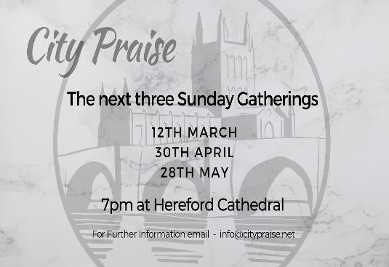
THY KINGDOM COME WEBINAR –

RESOURCES

Thank you so much to those who were
able to join us for the Inspire and Equip
webinar on 25
th

Janua
ry.

As promised, and for those who weren't
able to join, please see the link to the
Youtube session

her
e
.
We also attach a
copy of the slides from the session.

-----------------------------------------------------
The Light shines northward as the Year of Prayer inspires Telford
Deanery Team

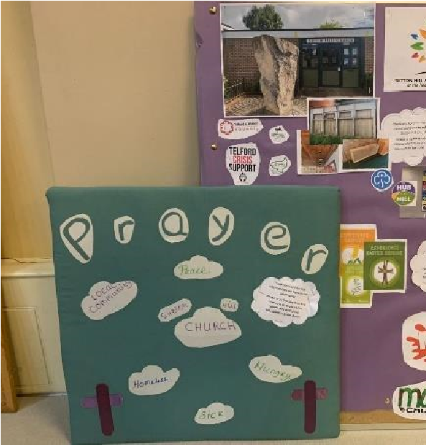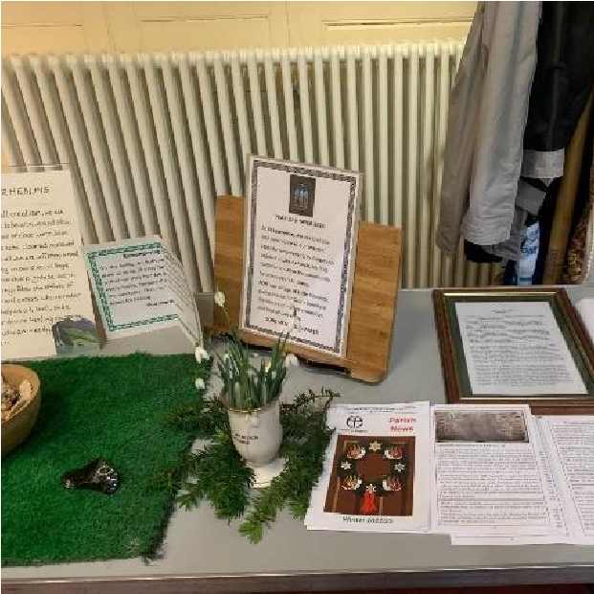

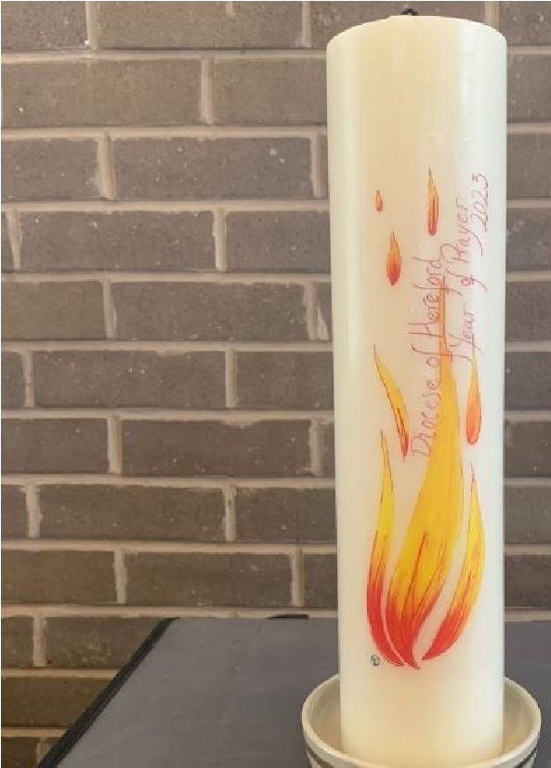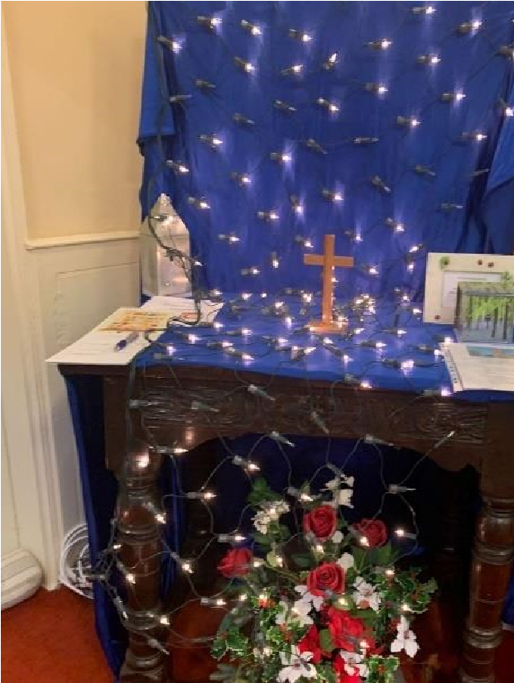

Churches representing Christians from across 7 parishes in south Shropshire came together earlier this month in a special Prayer service to mark the start of our Year of Prayer across the diocese.

The service followed the festival of light in January, where representatives from across the 400 plus churches of the diocese came together at Hereford Cathedral, and each deanery representative received a unique candle, blessed by the Dean, the Very Revd Sarah Brown and Bishop of Hereford, The Rt Revd Richard Jackson.

To read the full story, visit our website news.

Exploring Prayer Day 1 @ Craven Arms
Date: 1st April 2023
Time: 9:30am - 1:00pm
External Web
Link: https://www.eventbrite.c o.uk/e/exploring-prayer-day-1craven-arms-tickets477262443817
Related Page: Year of Prayer
2023
This event will take place at the Community Centre in
Craven Arms,
Shropshire. Further dates are planned throughout the year and you are welcome to attend any event.
For a full list of all the Year of Prayer events organised by Hereford Diocese, please visit our dedicated Year of Prayer page:
https://www.hereford.anglic an.org/our-faith/year-ofprayer-2023/
Please register for this event using the Eventbrite link below: https://www.eventbrite. co.uk/e/exploring-prayer-day-1craven-arms-tickets477262443817

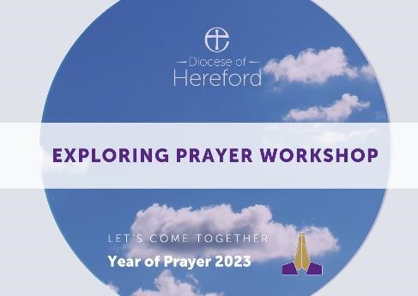
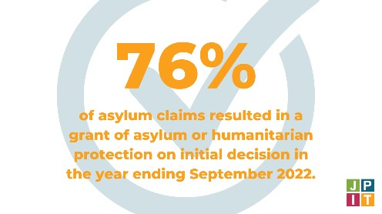

Updated
Briefing:
Asylum and Migration

Asylum has been a hot political topic in recent years. However, debates often seem to focus on refugees and asylum seekers as a problem to be managed or dealt with, and forget that at the heart of the matter are people on the move, who are often highly vulnerable.

Our updated briefing seeks to put the current debates in context, explore what a Christian response to these issues might look like, and point towards the steps that could be taken to build a fairer and more compassionate asylum system.

Our Churches have recently
spoken up on a number of issues facing refugees and asylum seekers in our communities.

If you want to find out more, please click on this link:

https://jpit.uk/refugeesbriefing20 23?utm_source=JPIT&utm_medi um=email&utm_campaign=1379 2025_Newsletter%20February% 202023&dm_i=1MV9,87LZT,543
8 FO,XOKRY,1
Joint Public Issues Team signed a joint letter calling for more Afghan families to be reunited, as promised as part of relocation following the evacuation of Afghanistan. Please click here to read the letter:
https://www.safepassage.org.uk/n ews/2023/1/17/dear-primeminister-help-afghan-familiesreunite?utm_source=JPIT&utm_me dium=email&utm_campaign=1379 2025_Newsletter%20February%20
2023&dm_i=1MV9,87LZT,5438FO,
XOKRZ,1

Joint Public Issues Team also joined hundreds of other organisations in calling for leaders to take a clear stand, after the attack on a Knowsley hotel housing asylum seekers. If you want to find out more, please click the link: https://togetherwithrefugees.or g.uk/call-for-a-clear-stand-frompolitical-leaders-after-attack-onknowsley-hotel/


How can we campaign
for climate justice locally? -

Webinars

Thursday 2 March 5:00pm

Are you or your church keen to get involved with our 'Net Zero in My Neighbourhood' campaign but want some support in approaching your councillors or members of local authority?

We’re partnering with our friends at Hope For The Future, who’ll share their expertise about best practice for approaching and engaging effectively with our local officials on issues to do with the climate crisis. We'll also be speaking about the importance of community and building a 'Net Zero in My Neighbourhood' network beyond.

The webinar will be run on Zoom, with opportunities to discuss and there will be interactive elements. We'll be running the webinar twice with the same content, so book whichever day and time is most convenient for you.
Click here to find out more
and sign up!

